IMT-2020-090 SHIKHAR GUPTA

# DE Assignment

# Short Answer problem 1;

What is a Decoder? Briefly explain BCD to decimal decoder.

A decoder is a combinational circuit that decrypts a given combination of bits to desired form . A decoder accepts the inputs that represent a N-binary number and activates only that output corresponding to the input number. All other outputs remain low/inactive.There are 2^n input combinations, for each of these input only one output will be HIGH /ACTIVE all other outputs are low .Some decoders have one or more ACTIVE(E) inputs that are used to control the operation of the decoder.

The BCD-to-decimal decoder or binary to octal cipher converts each BCD code (8421 code) into one of ten possible decimal digit indications.The method of implementation is the same as for the 1-of-16 decoder ,it is also called 4 to 10 decoder, except that only ten output gates are required because the BCD code contains only the ten decimal digits 0 through 9.

GENERAL 1 TO 16 DECODER::

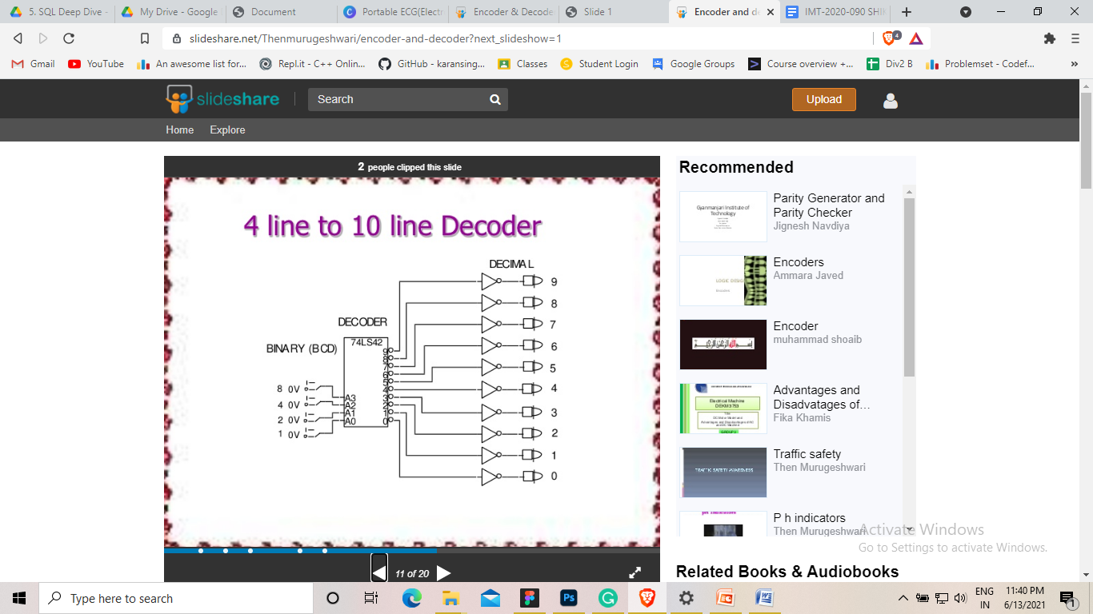

## SHORT ANSWER PROBLEM 2::

Make truth table and logic diagram for 2 x 4 decoder.

Block diagram of 2 to 4 decoder is shown in below A and B are the inputs.No. of Outputs : 2^2=4, they are indicated by D3 , D2 , D1 and D0 From the Truth Table obvious that each output is “1” for only specific combination of bits in inputs.

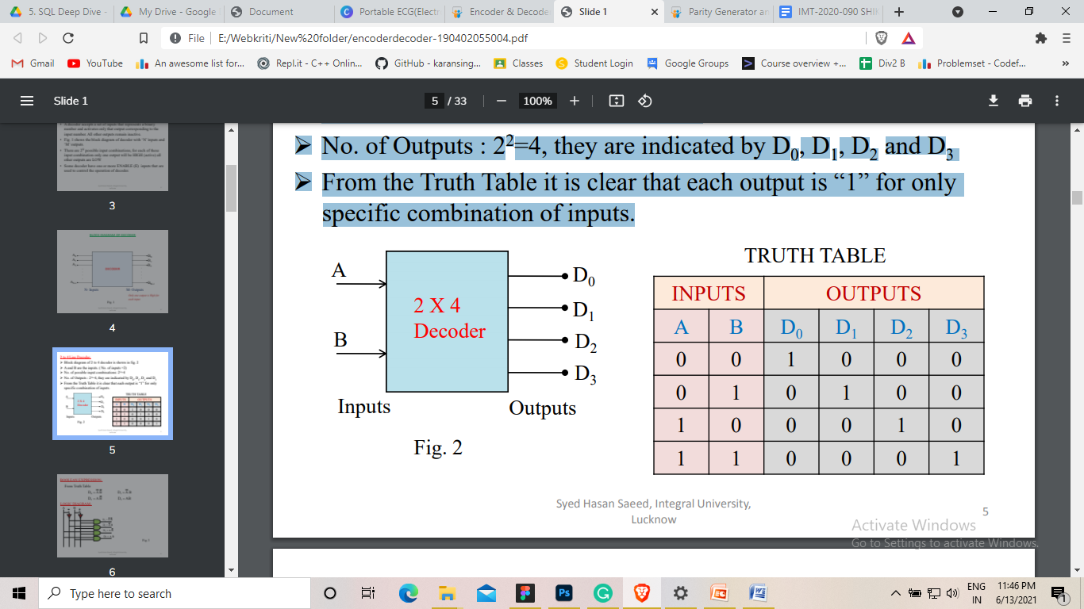

From Truth table::

D0=A’B’ D1=A’B D2=AB’ D3=AB

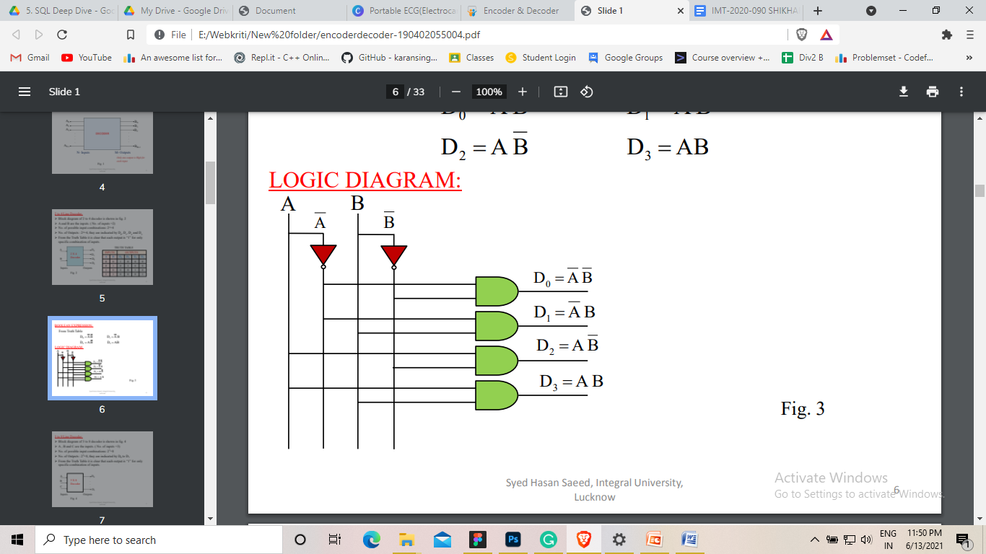

# LONG ANSWER Problem 1:

## What is an encoder, list different types of encoder?explain Priority encoder.

Solution::

An Encoder is a combinational logic circuit.It performs the opposite operation of Decoder.This process opposite of decoding is called as Encoding. An Encoder converts an HIGH/active input signal into a coded output signal. .An Encoder has ‘M’ input lines, An encoder accepts an HIGH level on one of its inputs representing a digit, such

as a Octal or decimal, and converts it to a coded output, such as BCD or binary.

The key difference between Decoder and Encoder is that Decoder has Binary Code as an input and produces and encrypted output such as BCD or Binary, while Encoder takes input as binary . Encoder is a device that converts the input data signal to digital stream of bits such as BCD Code.

Types of encoders: Priority Encoder, Decimal to BCD Encoder , Octal to Binary Encoder,Hexadecimal to Binary Encoder

Priority encoder::

A priority encoder also offers new addon property in that it can be used in applications that require priority detection.If more than one output line is ACTIVE/High corresponding to the highest-order decimal digit input that is high and will ignore any other lower-order active inputs. There are four inputs D3 , D2 ,D1, D0 in the figure and two outputs Y2 and Y1. D0 has lowest priority and D0 is at highest priority.

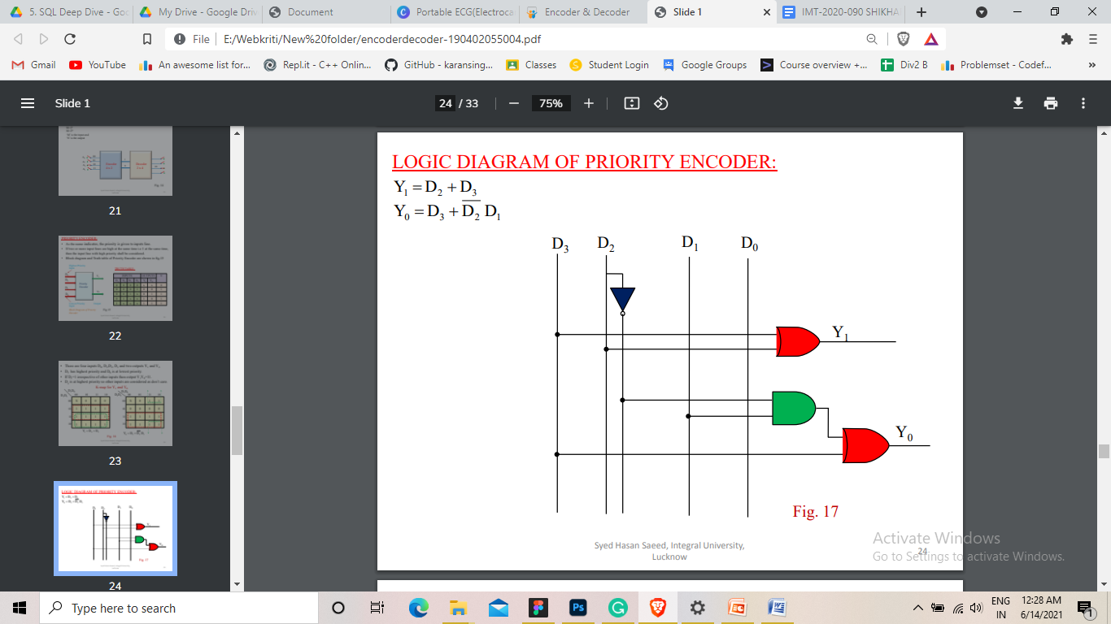

## 

# Long answer problem 2::

## Explain decimal to BCD encoder with logic diagram.

Solution::It has ten inputs corresponding to ten decimal digits (from 0 to 9) and four outputs (A,B,C,D) representing the BCD.

From the Truth Table it is clear that the output A is HIGH when input is 8 OR 9 is HIGH Therefore A=8+9. The output B is HIGH when 4 OR 5 OR 6 OR 7 is HIGH Therefore B=4+5+6+7.The output C is HIGH when 2 OR 3 OR 6 OR 7 is HIGH Therefore C=2+3+6+7. Similarly D=1+3+5+7+9.

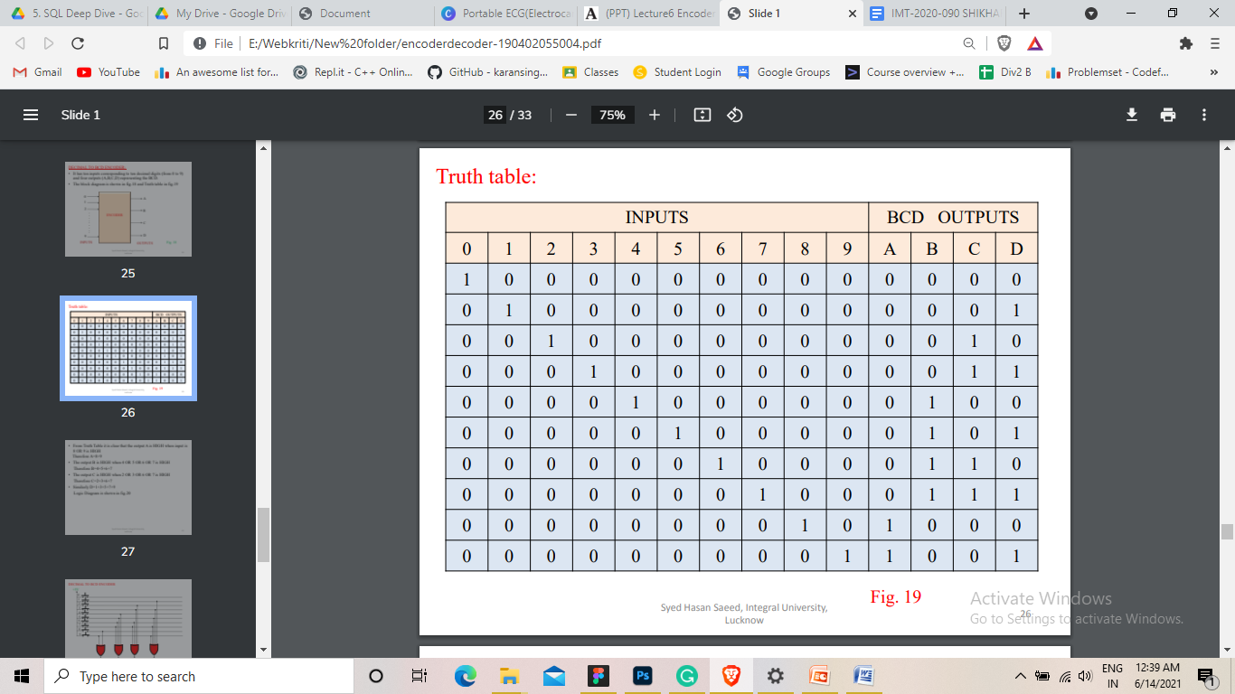

LOGIC DIAGRAM

